**NETWORKS LAB - UCS 2511**

**Assignment 11**

# **Performance Evaluation of TCP Congestion Control Algorithms**

**Name: Shaun Allan H**

**Reg No: 3122 22 5001 127**

**AIM:**

Use NS2 Simulator and evaluate the performance of the following TCP congestion Control Algorithms.

**TCP RENO:**

 # Create a simulator object

set ns [new Simulator]

# Open the NAM file and the trace file

set nf [open basic1.nam w]

$ns namtrace-all $nf

set tf [open basic1.tr w]

$ns trace-all $tf

# Define a 'finish' procedure

proc finish {} {

global ns nf tf

$ns flush-trace

close $nf

close $tf

exec nam basic1.nam &

exec xgraph reno.xg &

exit 0

}

# Create the network nodes

set n0 [$ns node]

set n1 [$ns node]

set n2 [$ns node]

# Create duplex links

$ns duplex-link $n0 $n1 10Mb 10ms DropTail

$ns duplex-link $n1 $n2 800Kb 50ms DropTail

# Set queue limit for the router

$ns queue-limit $n1 $n2 7

# Visual hints for NAM

$ns color 0 Red

$ns duplex-link-op $n0 $n1 orient right

$ns duplex-link-op $n1 $n2 orient right

$ns duplex-link-op $n1 $n2 queuePos 0.5

# Create and configure TCP sending agent

set tcp [new Agent/TCP/Reno]

$tcp set class_ 0

$tcp set window_ 100

$tcp set packetSize_ 960

$ns attach-agent $n0 $tcp

# Create and attach TCP receive agent (sink)

set sink [new Agent/TCPSink]

$ns attach-agent $n2 $sink

$ns connect $tcp $sink

# Schedule the data flow

set ftp [new Application/FTP]

$ftp attach-agent $tcp

$ns at 0.0 "$ftp start"

$ns at 10.0 "finish"

# Procedure to plot the congestion window

proc plotWindow {tcpSource outfile} {

global ns

set now [$ns now]

set cwnd [$tcpSource set cwnd_]

puts $outfile "$now $cwnd"

$ns at [expr $now + 0.1] "plotWindow $tcpSource $outfile"

}

# Open file to log congestion window

set outfile [open "reno.xg" w]

$ns at 0.0 "plotWindow $tcp $outfile"

# Run the simulation

$ns run



**Output:**

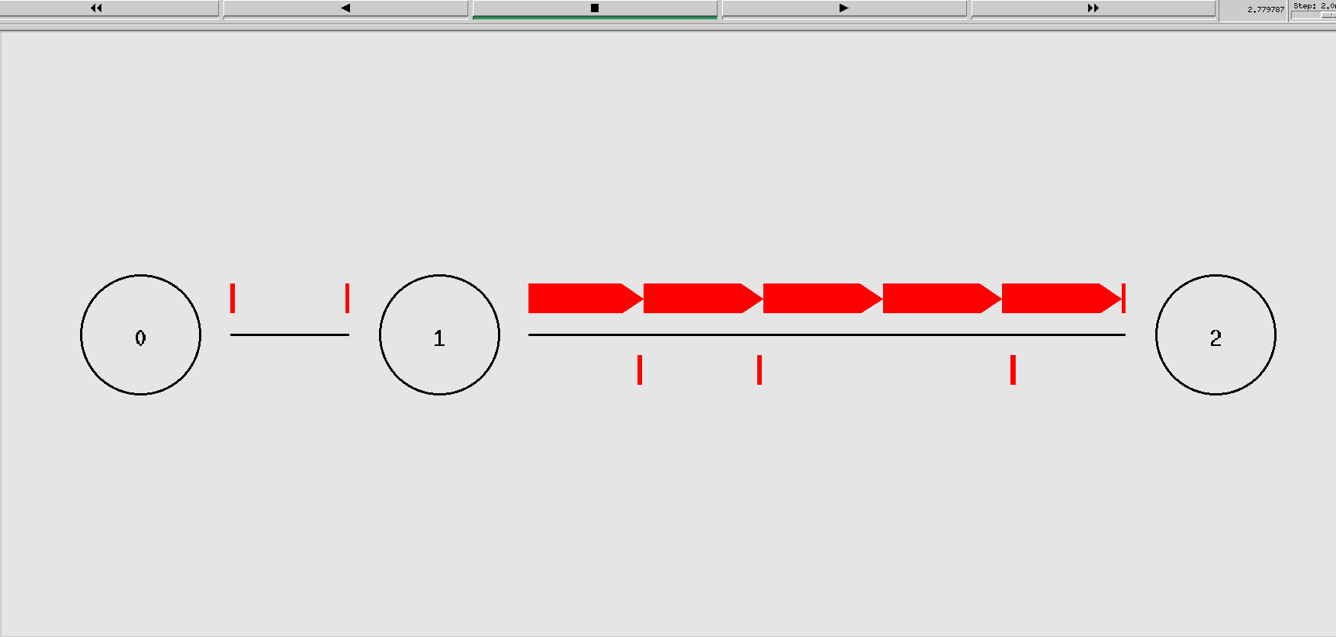

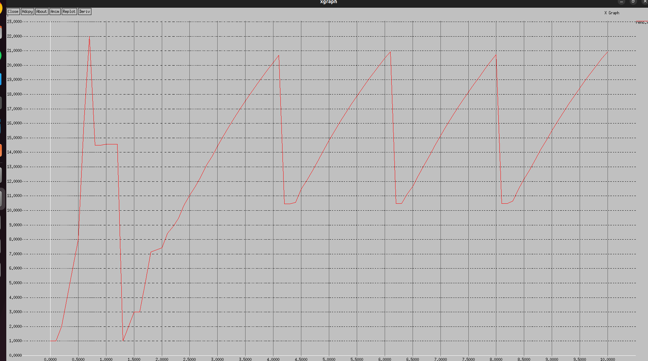

**TCP TAHOE:**

 # Create a simulator object

set ns [new Simulator]

# Define different colors for data flows (for NAM)

$ns color 1 Blue

$ns color 2 Red

# Open the NAM trace file

set nf [open taho.nam w]

$ns namtrace-all $nf

# Open the trace file for general simulation data

set tf [open taho.tr w]

$ns trace-all $tf

# Define a 'finish' procedure

proc finish {} {

global ns nf tf

$ns flush-trace

# Close the NAM trace file

close $nf

close $tf

# Execute NAM on the trace file

exec nam taho.nam &

exec xgraph taho.xg &

exit 0

}

# Create three nodes

set n0 [$ns node]

set n1 [$ns node]

set n2 [$ns node]

# Create links between the nodes

$ns duplex-link $n0 $n1 10Mb 10ms DropTail

$ns duplex-link $n1 $n2 2Mb 10ms DropTail

# Set Queue Size of link (n0-n1) to 10 packets

$ns queue-limit $n0 $n1 10

# Position nodes for visualization in NAM

$ns duplex-link-op $n0 $n1 orient right-down

$ns duplex-link-op $n1 $n2 orient right

# Monitor the queue for link (n0-n1). (for NAM)

$ns duplex-link-op $n0 $n1 queuePos 0.5

# Setup a TCP connection using the default TCP agent

set tcp [new Agent/TCP] ;# Use default TCP, which should be Tahoe

$tcp set window_ 10 ;# Set the window size (e.g., 10 packets)

$tcp set packetSize_ 1000 ;# Set the packet size (e.g., 1000 bytes)

$tcp set timeout_ 1.0 ;# Set the timeout (e.g., 1.0 seconds)

$ns attach-agent $n0 $tcp

# Create a TCP Sink on the destination node

set sink [new Agent/TCPSink]

$ns attach-agent $n2 $sink

$ns connect $tcp $sink

$tcp set fid_ 1

# Setup an FTP application over the TCP connection

set ftp [new Application/FTP]

$ftp attach-agent $tcp

# Schedule the FTP events

$ns at 0.1 "$ftp start"

$ns at 4.0 "$ftp stop"

# Call the finish procedure after 5 seconds of simulation time

$ns at 5.0 "finish"

# Procedure to plot the congestion window

proc plotWindow {tcpSource outfile} {

global ns

set now [$ns now]

set cwnd [$tcpSource set cwnd_]

# Record the data in a file

puts $outfile "$now $cwnd"

$ns at [expr $now + 0.1] "plotWindow $tcpSource $outfile"

}

# Prepare to record the congestion window

set outfile [open "taho.xg" w]

$ns at 0.0 "plotWindow $tcp $outfile"

# Run the simulation

$ns run



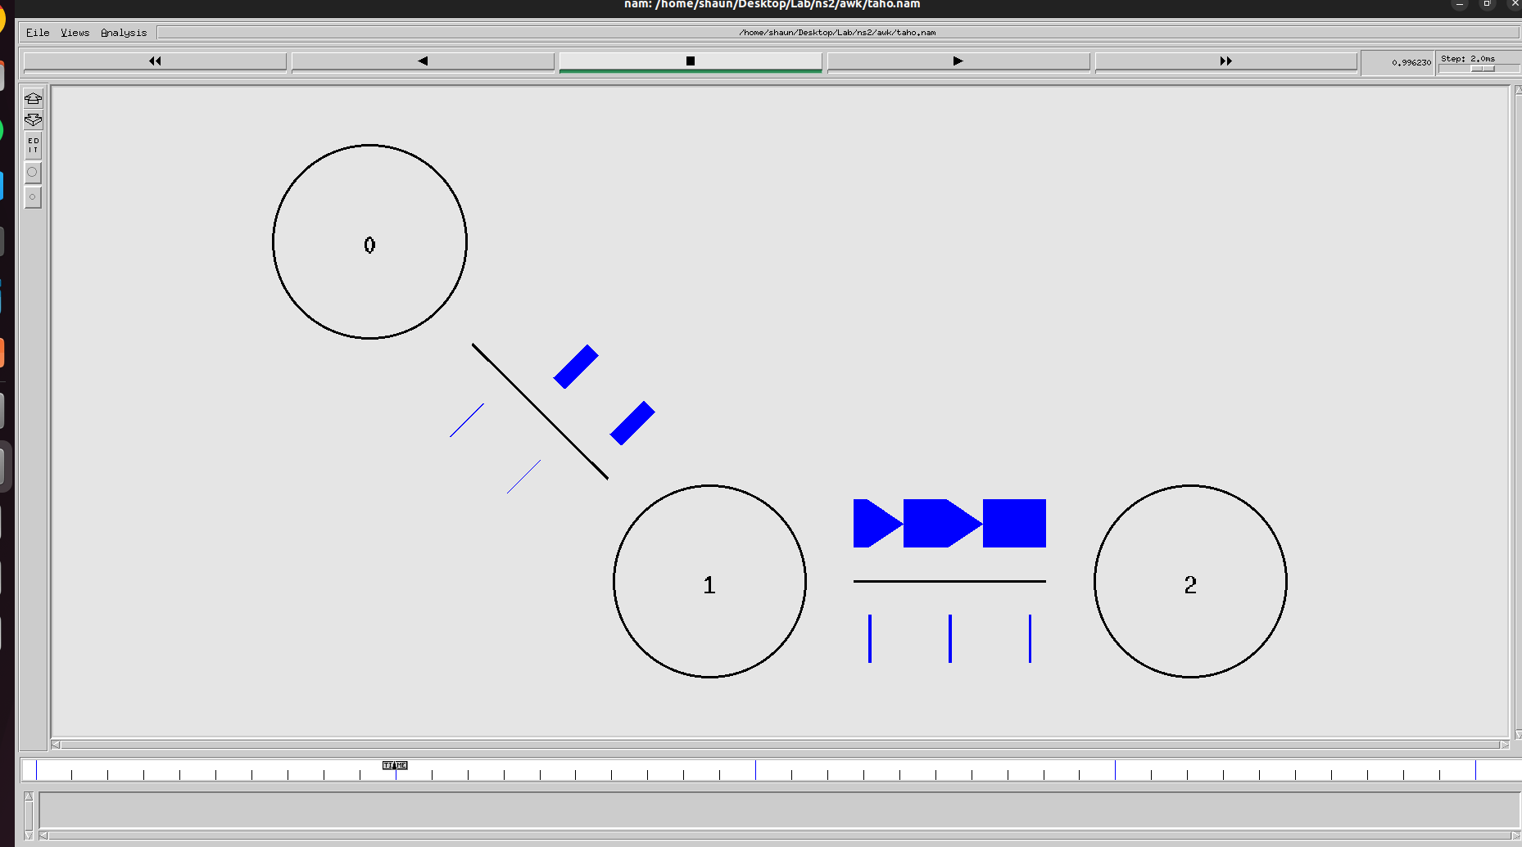

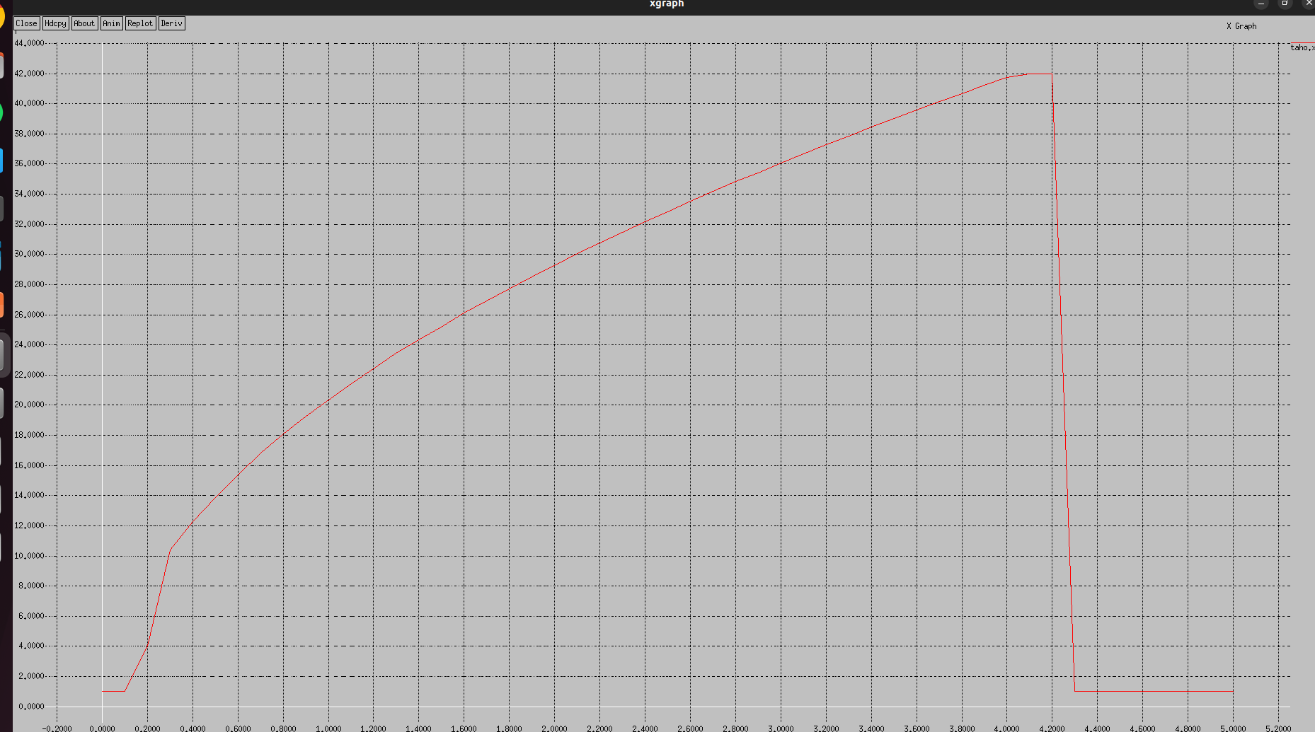

**TCP NEWRENO:**

 # Create a simulator object

set ns [new Simulator]

# Open the NAM file and the trace file

set nf [open basic1.nam w]

$ns namtrace-all $nf

set tf [open basic1.tr w]

$ns trace-all $tf

# Define a 'finish' procedure

proc finish {} {

global ns nf tf

$ns flush-trace

close $nf

close $tf

exec nam basic1.nam &

exec xgraph reno.xg &

exit 0

}

# Create the network nodes

set n0 [$ns node]

set n1 [$ns node]

set n2 [$ns node]

# Create duplex links

$ns duplex-link $n0 $n1 10Mb 10ms DropTail

$ns duplex-link $n1 $n2 800Kb 50ms DropTail

# Set queue limit for the router

$ns queue-limit $n1 $n2 7

# Visual hints for NAM

$ns color 0 Red

$ns duplex-link-op $n0 $n1 orient right

$ns duplex-link-op $n1 $n2 orient right

$ns duplex-link-op $n1 $n2 queuePos 0.5

# Create and configure TCP sending agent

set tcp [new Agent/TCP/Reno]

$tcp set class_ 0

$tcp set window_ 100

$tcp set packetSize_ 960

$ns attach-agent $n0 $tcp

# Create and attach TCP receive agent (sink)

set sink [new Agent/TCPSink]

$ns attach-agent $n2 $sink

$ns connect $tcp $sink

# Schedule the data flow

set ftp [new Application/FTP]

$ftp attach-agent $tcp

$ns at 0.0 "$ftp start"

$ns at 10.0 "finish"

# Procedure to plot the congestion window

proc plotWindow {tcpSource outfile} {

global ns

set now [$ns now]

set cwnd [$tcpSource set cwnd_]

puts $outfile "$now $cwnd"

$ns at [expr $now + 0.1] "plotWindow $tcpSource $outfile"

}

# Open file to log congestion window

set outfile [open "reno.xg" w]

$ns at 0.0 "plotWindow $tcp $outfile"

# Run the simulation

$ns run



**Output:**





**TCP TAHOE:**

 # Create a simulator object

set ns [new Simulator]

# Define different colors for data flows (for NAM)

$ns color 1 Blue

$ns color 2 Red

# Open the NAM trace file

set nf [open taho.nam w]

$ns namtrace-all $nf

# Open the trace file for general simulation data

set tf [open taho.tr w]

$ns trace-all $tf

# Define a 'finish' procedure

proc finish {} {

global ns nf tf

$ns flush-trace

# Close the NAM trace file

close $nf

close $tf

# Execute NAM on the trace file

exec nam taho.nam &

exec xgraph taho.xg &

exit 0

}

# Create three nodes

set n0 [$ns node]

set n1 [$ns node]

set n2 [$ns node]

# Create links between the nodes

$ns duplex-link $n0 $n1 10Mb 10ms DropTail

$ns duplex-link $n1 $n2 2Mb 10ms DropTail

# Set Queue Size of link (n0-n1) to 10 packets

$ns queue-limit $n0 $n1 10

# Position nodes for visualization in NAM

$ns duplex-link-op $n0 $n1 orient right-down

$ns duplex-link-op $n1 $n2 orient right

# Monitor the queue for link (n0-n1). (for NAM)

$ns duplex-link-op $n0 $n1 queuePos 0.5

# Setup a TCP connection using the default TCP agent

set tcp [new Agent/TCPNewreno] ;# Use default TCP, which should be Tahoe

$tcp set window_ 10 ;# Set the

window size (e.g., 10 packets)

$tcp set packetSize_ 1000 ;# Set the packet size (e.g., 1000 bytes)

$tcp set timeout_ 1.0 ;# Set the timeout (e.g., 1.0 seconds)

$ns attach-agent $n0 $tcp

# Create a TCP Sink on the destination node

set sink [new Agent/TCPSink]

$ns attach-agent $n2 $sink

$ns connect $tcp $sink

$tcp set fid_ 1

# Setup an FTP application over the TCP connection

set ftp [new Application/FTP]

$ftp attach-agent $tcp

# Schedule the FTP events

$ns at 0.1 "$ftp start"

$ns at 4.0 "$ftp stop"

# Call the finish procedure after 5 seconds of simulation time

$ns at 5.0 "finish"

# Procedure to plot the congestion window

proc plotWindow {tcpSource outfile} {

global ns

set now [$ns now]

set cwnd [$tcpSource set cwnd_]

# Record the data in a file

puts $outfile "$now $cwnd"

$ns at [expr $now + 0.1] "plotWindow $tcpSource $outfile"

}

# Prepare to record the congestion window

set outfile [open "taho.xg" w]

$ns at 0.0 "plotWindow $tcp $outfile"

# Run the simulation

$ns run

**OUTPUT:**

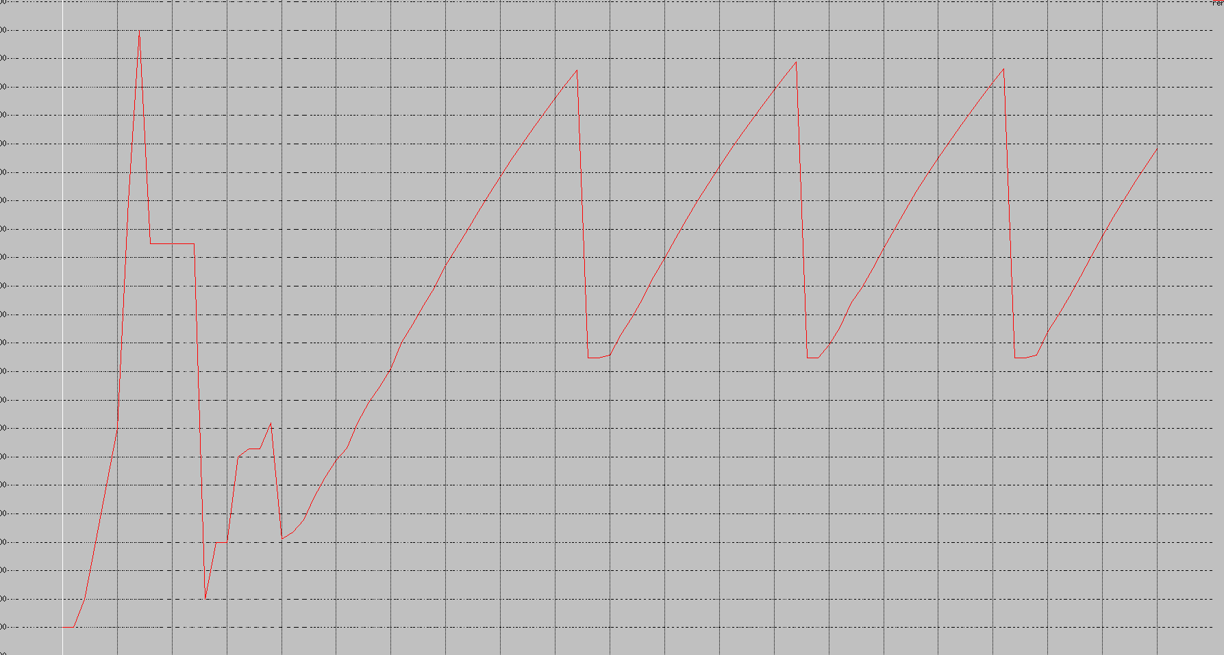

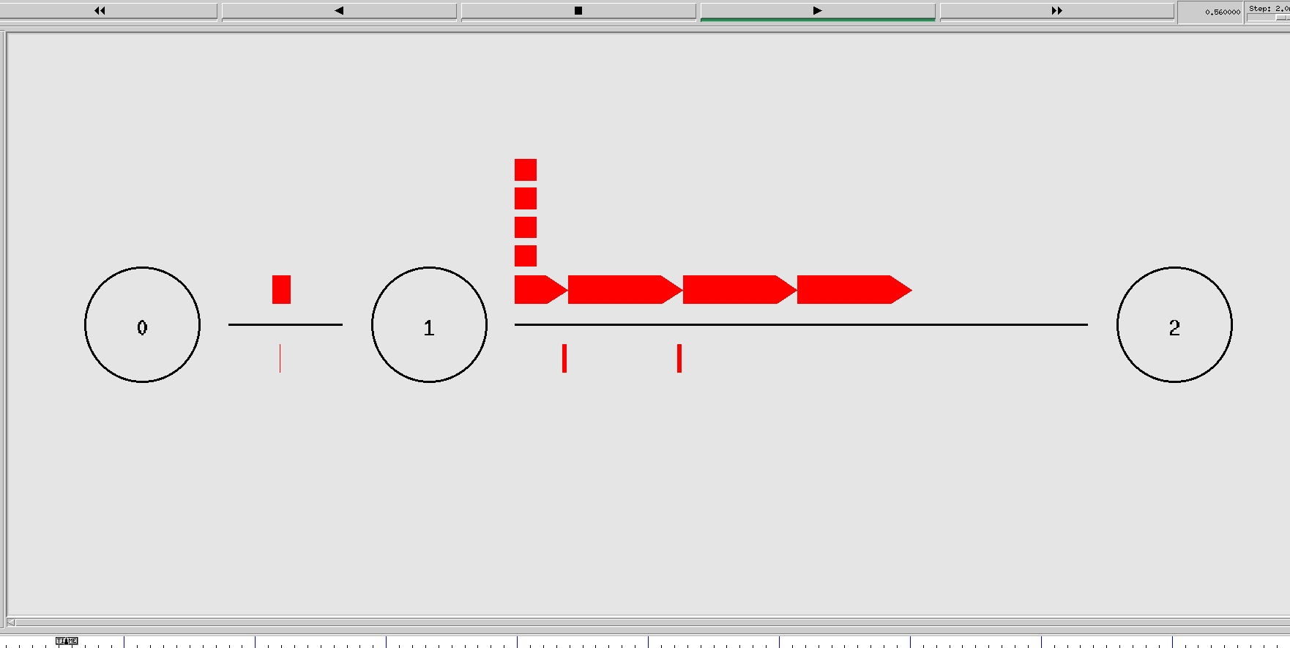

**TCP STACK:**

 # Create a simulator object

set ns [new Simulator]

# Define different colors for data flows (for NAM)

$ns color 1 Blue

$ns color 2 Red

# Open the NAM trace file

set nf [open taho.nam w]

$ns namtrace-all $nf

# Open the trace file for general simulation data

set tf [open taho.tr w]

$ns trace-all $tf

# Define a 'finish' procedure

proc finish {} {

global ns nf tf

$ns flush-trace

# Close the NAM trace file

close $nf

close $tf

# Execute NAM on the trace file

exec nam taho.nam &

exec xgraph taho.xg &

exit 0

}

# Create three nodes

set n0 [$ns node]

set n1 [$ns node]

set n2 [$ns node]

# Create links between the nodes

$ns duplex-link $n0 $n1 10Mb 10ms DropTail

$ns duplex-link $n1 $n2 2Mb 10ms DropTail

# Set Queue Size of link (n0-n1) to 10 packets

$ns queue-limit $n0 $n1 10

# Position nodes for visualization in NAM

$ns duplex-link-op $n0 $n1 orient right-down

$ns duplex-link-op $n1 $n2 orient right

# Monitor the queue for link (n0-n1). (for NAM)

$ns duplex-link-op $n0 $n1 queuePos 0.5

# Setup a TCP connection using the default TCP agent

set tcp [new Agent/TCPFull];# Use default TCP, which should be Tahoe

$tcp set window_ 10 ;# Set the

window size (e.g., 10 packets)

$tcp set packetSize_ 1000 ;# Set the packet size (e.g., 1000 bytes)

$tcp set timeout_ 1.0 ;# Set the timeout (e.g., 1.0 seconds)

$ns attach-agent $n0 $tcp

# Create a TCP Sink on the destination node

set sink [new Agent/TCPSink]

$ns attach-agent $n2 $sink

$ns connect $tcp $sink

$tcp set fid_ 1

# Setup an FTP application over the TCP connection

set ftp [new Application/FTP]

$ftp attach-agent $tcp

# Schedule the FTP events

$ns at 0.1 "$ftp start"

$ns at 4.0 "$ftp stop"

# Call the finish procedure after 5 seconds of simulation time

$ns at 5.0 "finish"

# Procedure to plot the congestion window

proc plotWindow {tcpSource outfile} {

global ns

set now [$ns now]

set cwnd [$tcpSource set cwnd_]

# Record the data in a file

puts $outfile "$now $cwnd"

$ns at [expr $now + 0.1] "plotWindow $tcpSource $outfile"

}

# Prepare to record the congestion window

set outfile [open "taho.xg" w]

$ns at 0.0 "plotWindow $tcp $outfile"

# Run the simulation

$ns run



**Learning Outcomes:**

* I learnt to use ns2 and nam to simulate network flow
* I analyzed and understood the working of different congestion methods of TCP.